**Solution Template 3 -AMI and EBS**

Due: Saturday, Sept 29 11:59PM

**Name:**

**Problem 1: AMI Creation (30 Points)**

**a)** To check that you have stood up a webpage with your biography content from the Apache web server deployed on the 1st instance

i) either provide the URL to the webpage that staff can access that should display your biography in the box below:

(or)

ii) Paste the screenshot of the biography webpage retrieved from server-1 in the box below

|  |
| --- |
|  |

**b)** To check that you have stood up a webpage with your biography & photo Apache web server deployed on the 2nd instance that is created through the AMI of the above instance

i) either provide the URL to the webpage that staff can access that should display your biography in the box below:

(or)

ii) Paste the screenshot of the biography webpage retrieved from server-2 in the box below

|  |
| --- |
| [Bio page: http://ec2-54-159-62-86.compute-1.amazonaws.com/](http://ec2-54-159-62-86.compute-1.amazonaws.com/)  [Image: http://ec2-35-153-140-196.compute-1.amazonaws.com/alex.jpg](http://ec2-35-153-140-196.compute-1.amazonaws.com/alex.jpg) |

**Problem 2: AMI Distribution (10 Points)**

Once the AMI is created in Problem-1, Select your AMI, go to **Actions** tab, share it only with the TA assigned to you by referring to the TA’s AWS account-id.

Then,Select the AMI in the list, and choose permissions tab , Paste the screenshot of the page that shows you shared the AMI with another account, below:

|  |
| --- |
| Assigned TA is Sergei |

**Problem 3: EBS (30 Points)**

1. Create an EC2 instance using AMI of Problem-1, log in to the instance.

To display that you have actually created an EBS volume , list all the volumes mounted on the instance using below command. Along with some temporary file systems, it should display root volume and additional volume that you would create.

|  |
| --- |
| **df** |

Share the output of the above command here:

|  |
| --- |
|  |

b) create a directory in that additional volume and name it web-content

c) Move the biography page , photo that are part of the AMI into web-content directory. Change to web-content directory. To make sure contents are copied, run the below command to list the contents of the directory

|  |
| --- |
| ls |

d) From EC2 dashboard on AWS console, choose snapshots in the navigation pane. Create a snapshot from the additional volume you created above.

e) Choose any of the ec2 instances you created, other than the one created in the current problem. In details pane, you can inspect the information provided about root and block devices.

Take a screenshot of that info and paste here:

|  |
| --- |
| Pre adding the new volume |

f) Choose EBS Volumes from the navigation pane, and create a volume from the snapshot created in sub-step (d) above. Select the volume that is created, and attach it to to that EC2 instance that you choose. Take a screenshot of the volumes attached and paste here:

|  |
| --- |
|  |

h) Once attached, you need to mount the volume on to the instance to be able to view the web-content directory on the ec2 instance that you attached it to.

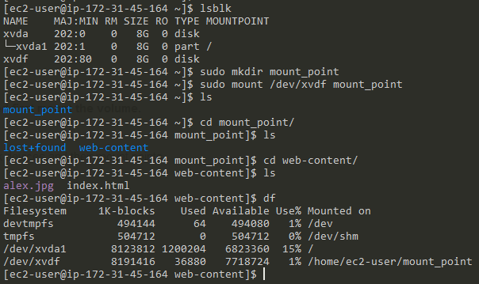

**Problem 4: AMI Configuration (30 Points)**

capture the below three pieces of the information in both cases

***before changing the instance type of the instance created,***

1. Screenshot of the ec2 instance type from the console or from the command output of the instance metadata

|  |
| --- |
|  |

b) screenshot for the memory & root file system info of the instance obtained from the unix commands

|  |
| --- |
|  |

***After changing the instance type of the instance,***

c) Screenshot of the ec2 instance type from the console or from the command output of the instance metadata

|  |
| --- |
|  |

d) screenshot for the memory & root file system info of the instance obtained from the unix commands

|  |
| --- |
|  |

**BONUS Problem 5 (15 Points):**

Once the appropriate curl command is constructed,

1. paste the curl command used and its command here:

|  |
| --- |
| After login to the instance:  Metadata listing: curl <http://169.254.169.254/latest/meta-data/>  Instance id: curl <http://169.254.169.254/latest/meta-data/instance-id> |

b) paste the screenshot of the instance-type information seen on the EC2 dashboard from AWS Console

|  |
| --- |
|  |